**ContactUS** [**https://ecerasystem.com/contact**](https://ecerasystem.com/contact)

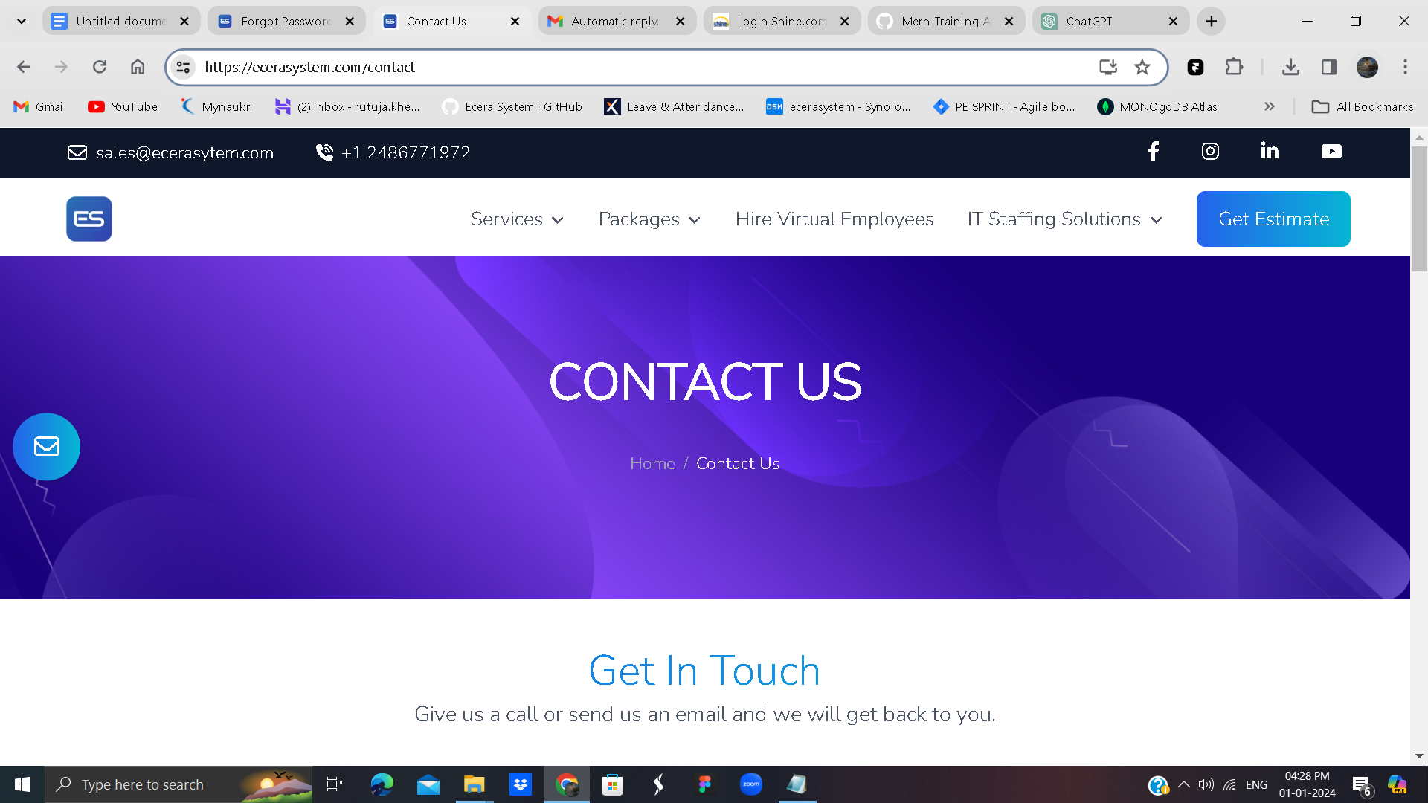

The ContactUs component is a React functional component designed to render a Contact Us page within a React application. Below is an explanation of the code:

Component Structure:

Import Statements:

Imports necessary React components - Header, PageTitle, and Footer - from the specified paths.

Component Function:

Declares the ContactUs functional component.

Return Statement:

Returns JSX code representing the structure of the Contact Us page.

PageTitle Component:

Renders a PageTitle component, providing the title "Contact us."

Header Component:

Includes a Header component, representing the header section of the page.

Background Image:

Sets a background image for the main section of the Contact Us page using Tailwind CSS classes.

The image is specified as url(/images/hp-img-closer-bg.png).

Section Container:

Utilizes Flexbox to create a responsive layout with justified content.

Text Content:

Contains text content within two columns (lg:w-1/2 each):

Left Column (lg:text-start for large screens, text-center for small screens):

Displays a heading, subtext, and a link to contact the sales team.

Right Column:

Currently commented out ({/* <img src={qnaImg} alt="" className='mx-auto' loading='lazy'/> */}), waiting for an image.

Footer Component:

Renders a Footer component at the bottom of the Contact Us page.

Usage:

Import this component into the parent component where the Contact Us page is needed.

It automatically includes the header, background image, and footer.

Styling:

Utilizes Tailwind CSS classes for styling, creating a visually appealing and responsive design.

This component provides a structured layout for a Contact Us page, offering information and a link for users to reach out to the sales team.